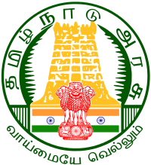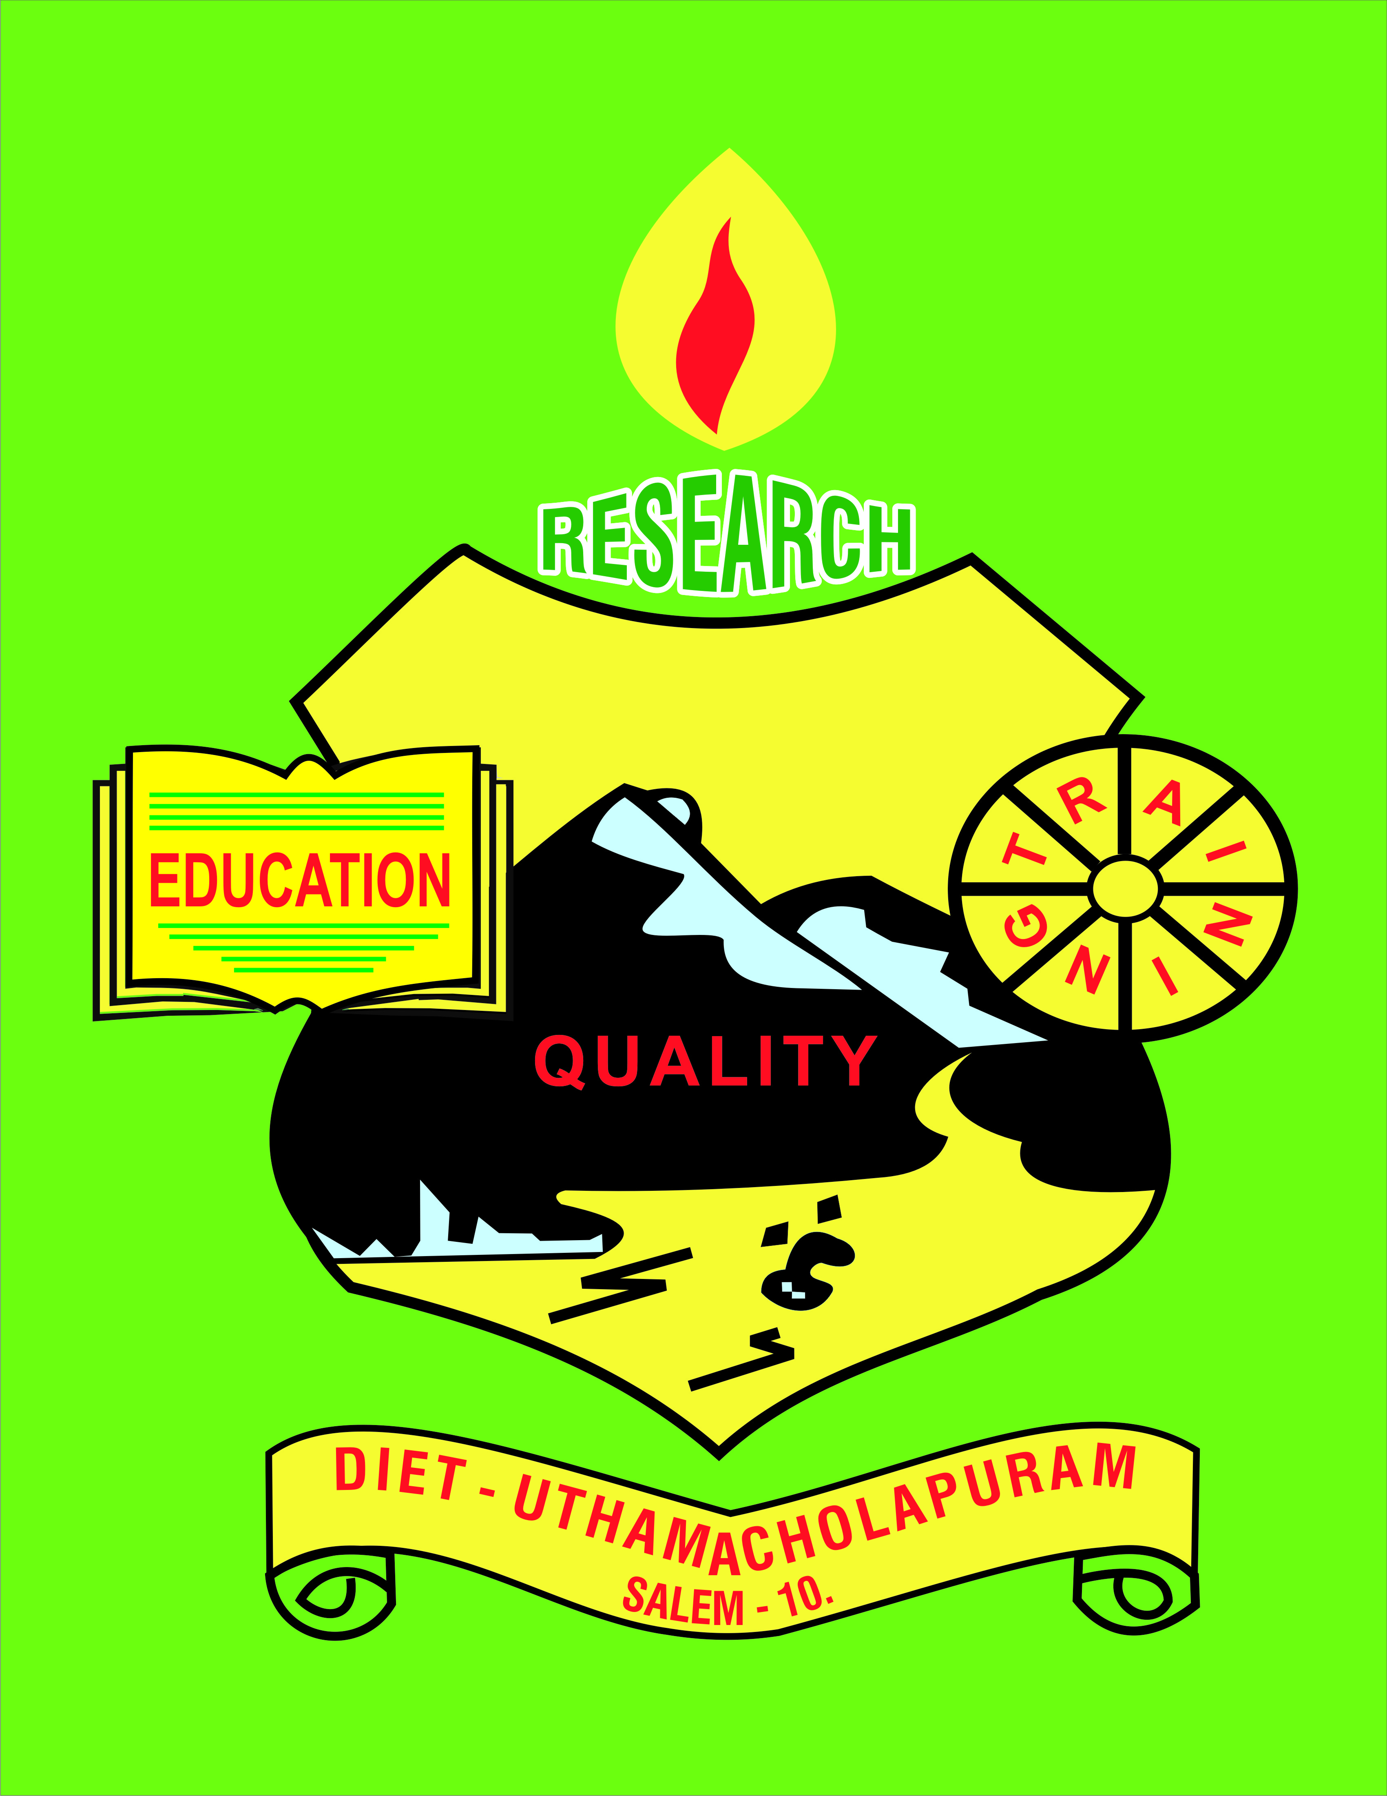

Uthamacholpuram-636010
February– 2022 PREPARED BY: ET-Branch Vol: 5 No: 2
SPECTRUM
ECHO OF DIET SALEM
EE
Ece

Formulation of Hypothesis*

Formulation of Hypothesis:
The word hypothesis consists of two words–Hypo+Thesis. ‘Hypo’ means tentative or subject to the verification. ‘Thesis’ means statement about solution of the problem. Thus the literal meaning of the term hypothesis is a tentative statement about the solution of the problem. Hypothesis offers a solution of the problem that is to be verified empirically and based on some rationale.

Definitions of Hypothesis:
“Any supposition which we make in order to endeavor to deduce conclusions in accordance with facts which are known to be real under the idea that if the conclusions to which the hypothesis leads are known truths, the hypothesis itself either must be or at least likely to be true.”
J.S. Mill

“A hypohesis is “ a tentative generalization the validity of which remains to be tested. In its most elementary stage the hypothesis may be any hunch, guess, imaginative idea which becomes basis for further investigation.”
Lundberg
Nature of Hypothesis:
- Conceptual: Some kind of conceptual elements in the framework are involved in a hypothesis.
- Verbal statement in a declarative form: It is a verbal expression of ideas and concepts. It is not merely mental idea but in the verbal form, the idea is ready enough for empirical verification.
- It represents the tentative relationship between two or more variables.
- Forward or future oriented: A hypothesis is future-oriented. It relates to the future verification not the past facts and information.
- Pivot of a scientific research: All research activities are designed for verification of hypothesis.

Functions of Hypothesis:
H.H. Mc Ashan has mentioned the following functions of hypothesis;
- It is a temporary solution of a problem concerning with some truth which enables an investigator to start his research works.
- It offers a basis in establishing the specifics what to study for and may provide possible solutions to the problem.
- It may lead to formulate another hypothesis.
- A preliminary hypothesis may take the shape of final hypothesis.
- Each hypothesis provides the investigator with definite statement which may be objectively tested and accepted or rejected and leads for interpreting results and drawing conclusions that is related to original purpose.
- It delimits field of the investigation.
- It sensitizes the researcher so that he should work selectively, and have very realistic approach to the problem.
- It offers the simple means for collecting evidences for verification.

Importance of a Hypothesis:
- Investigator’s eyes: Carter V. Good thinks that by guiding the investigator in further investigation hypothesis serves as the investigator’s eyes in seeking answers to tentatively adopted generalization.
- Focuses research: Without hypothesis, a research is unfocussed research and remains like a random empirical wandering. Hypothesis serves as necessary link between theory and the investigation.
- Clear and specific goals: A well thought out set of hypothesis places clear and specific goals before the research worker and provides him with a basis for selecting sample and research procedure to meet these goals.
- Links together: According to Barr and Scates, “It serves the important function of linking together related facts and information and organizing them into wholes.”
- Prevents blind research: In the words of P.V. Young,”The use of hypothesis prevents a blind search and indiscriminate gathering of masses of data which may later prove irrelevant to the problem understudy."
- Guiding Light:”A hypothesis serves as powerful beacon that light the way for the research work.”
- It provides direction to research and prevent the review of irrelevant literature and the collection of useful or excess data.
- It sensitizes the investigator certain aspects of situation which are irrelevant from the standpoint of problem at hand.
- It enables the investigator to understand with greater clarity his problem and its ramification.

- It is an indispensible research instrument, for it builds a bridge between the problem and the location of empirical evidence that may solve the problem.
- It provides the investigator with the most efficient instrument for exploring and explaining the unknown facts.
- It provides a frame work for drawing conclusion.
- It stimulates the investigator for further research.

Forms of Hypothesis:
According to Bruce W. Tuckman following are the forms of hypothesis;

Question form:
A hypothesis stated as a question represents the simplest level of empirical observation. It fails to fit most definitions of hypothesis. It frequently appears in the list. There are cases of simple investigation which can be adequately implemented by raising a question, rather than dichotomizing the hypothesis forms into acceptable / rejects able categories.

Declarative Statement:
A hypothesis developed as a declarative statement provides an anticipated relationship or difference between variables. Such a hypothesis developer has examined existing evidence which led him to believe that a difference may be anticipated as additional evidence. It is merely a declaration of the independent variables effect on the criterion variable.

Directional Hypothesis:
A directional hypothesis connotes an expected direction in the relationship or difference between variables. This type of hypothesis developer appears more certain of anticipated evidence. If seeking a tenable hypothesis is the general interest of the researcher, this hypothesis is less safe than the others because it reveals two possible conditions

Non –Directional Hypothesis or Null Hypothesis:
This hypothesis is stated in the null form which is an assertion that no relationship or no difference exists between or among the variables. Null hypothesis is a statistical hypothesis testable within the framework of probability theory. It is a non-directional form of hypothesis.

Formulation of Testable Hypothesis:
A hypothesis is a tentative assumption drawn from knowledge and theory. It is used as a guide in the investigation of other facts and theory that are as yet unknown. Its formulation is one of the most difficult and most crucial step in the entire scientific process. A poorly chosen or poorly worded hypothesis can prevent the following:
  - The obtaining of enough pertinent data,
  - The drawing of conclusions and generalizations ,and
  - The application of certain statistical measures in the analysis of the result.

Fundamental Basis of Hypothesis:
The researcher deals with reality on two levels;

The Operational Level:
On the operational level researcher must define events in observable terms in order to operate with the reality necessary to do researches.

The Conceptual Level:
On the conceptual level the researcher must define events in terms of underlying communality with other events. Defining at a conceptual level, the researcher can abstract from single specific to general instance and begin to understand how phenomena operate and variables interrelate.
*copyright

FEBRUARY - 2022 Month Activities:
01.02.2022 | Action Research – Zonal Level – District Institute of Education and Training-Krishnagiri.  English Dictionary Work.  NISHTHA – module pruning work at SCERT, Chennai.  AWP&B Work.
02.02.2022 | English Dictionary Work.  NISHTHA – module pruning work at SCERT, Chennai.  AWP&B Work.
03.02.2022 | Accountant General – Performance Auditing Guidelines and Preparatory Work.  NISHTHA – module pruning work at SCERT, Chennai.  AWP&B Work.  AWP&B Consolidation work by Mr B.Uthayakumar, Lecturer at SCERT, Chennai.  English Dictionary Work.
04.02.2022 | NISHTHA – Module pruning work at SCERT, Chennai.  AWP&B Work.  AWP&B Consolidation work by Mr B.Uthayakumar, Lecturer at SCERT, Chennai.
07.02.2022 | AWP&B Consolidation work by Mr B.Uthayakumar, Lecturer at SCERT, Chennai.
08.02.2022 | AWP&B Consolidation work by Mr B.Uthayakumar, Lecturer at SCERT, Chennai.
09.02.2022 | Taxonomy – Review work for 10th standard Science by Dr S.V.Vijayalakmi Shankar, Senior Lecturer.  Annual Work Plan & Budget (2022-2023).  NISHTHA module pruning work.  Action Research Data Analysis.  SCERT, DIET – Capacity Building workshop at at Yelagiri.
10.02.2022 | Taxonomy – Review work for 10th standard Science by Dr S.V. Vijayalakmi Shankar, Senior Lecturer.  Annual Work Plan & Budget (2022-2023).  NISHTHA module pruning work.  Action Research Data Analysis.  SCERT, DIET – Capacity Building workshop at Yelagiri.
11.02.2022 | Taxonomy – Review work for 10th standard Science by Dr S.V. Vijayalakmi Shankar, Senior Lecturer.  Annual Work Plan & Budget (2022-2023).  NISHTHA module pruning work.  Action Research Data Analysis.  SCERT, DIET – Capacity Building workshop at Yelagiri.
14.02.2022 | Taxonomy – Review work for 10th standard Science by  Dr S.V. Vijayalakmi Shankar, Senior Lecturer.  Health and well being module for NISHTHA was reframed.  Taxonomy – Review work for Chemistry.  Yoga Training for Girls – 9th to 12th standard at DIET, Coimbatore organized by Dr S. Peter Anandh, Lecturer.
15.02.2022 | Taxonomy – Review work for 10th standard Science byDr S.V. Vijayalakmi Shankar, Senior Lecturer.  Taxonomy – Review work for Chemistry.  Health and well being module for NISHTHA was reframed.  Yoga Training for Girls – 9th to 12th standard at DIET, Coimbatore organized by Dr S. Peter Anandh, Lecturer.  Framing of New MCQ for Chemistry +1, +2 is carried out.  SMC Training – District Level Training is held at AVS Engineering College, Ammapet -Dr K. Kannaki, Senior Lecturer participated.
16.02.2022 | Taxonomy – Review work for 10th standard Science by Dr S.V. Vijayalakmi Shankar, Senior Lecturer.  Health and well being module for NISHTHA was reframed.  Yoga Training for Girls – 9th to 12th standard at DIET, Coimbatore organized by  Dr S. Peter Anandh, Lecturer.  Framing of New MCQ for Chemistry +1, +2 is carried out.  SMC Training – District Level Training is held at AVS Engineering College, Ammapet -Dr K. Kannaki, Senior Lecturer participated.
17.02.2022 | Taxonomy – Review work for 10th standard Science by Dr S.V. Vijayalakmi Shankar, Senior Lecturer.  Health and well being module for NISHTHA was reframed.  Yoga Training for Girls – 9th to 12th standard at Coimbatore DIET organized by  Dr S. Peter Anandh, Lecturer.  Framing of New MCQ for Chemistry +1, +2 is carried out.  Action Research and Research Project.  Digital content support initiative work.
18.02.2022 | Yoga Training for Girls – 9th to 12th standard at DIET, Coimbatore organized by Dr S. Peter Anandh, Lecturer.  Action Research and Research Project.  Digital content support initiative work.  Taxonomy – Review work for 10th standard Science by  Dr S.V. Vijayalakmi Shankar, Senior Lecturer.  Taxonomy – Review work for Chemistry.
21.02.2022 | School Leadership case study workshop.  Action Research and Research Project.  Science e-Quiz Preparation.
22.02.2022 | Accountant General performance Audit.  School Leadership case study documentation workshop.  Action Research and Research Project.  Science e-Quiz Preparation.
23.02.2022 | Accountant General performance Audit.  School Leadership case study documentation workshop.
24.02.2022 | Life Skill Education - District Level competition selection.  School Leadership case study documentation workshop.  Action Research and Research Project.
25.02.2022 | School Leadership case study documentation workshop.  Action Research and Research Project.
28.02.2022 | School Leadership case study documentation workshop.  Action Research and Research Project.

Dr M.Selvam, Principal
- Participated in ZARC -Action research zonal meeting at DIET, Krishnagiri on 01.02.2022.
- Visited Learning Outcomes Reinforcement training at GHS, Kamalapuram on 02.02.2022.
- Presided “Aasaan Avai” Webinar series on 06.02.2022, 12.02.2022, 20.02.2022 and 27.02.2022.
Planning and Management Branch (P&M):
Dr K.Kannaki, Senior Lecturer
- 4.2.2022 –DIET Civil Work Budget Preparation and Construction of New Toilet Rooms Budget Preparation work was seen.
- 7.2.2022 & 8.2.2022 – Annual Work Plan& Budget for the Year 2022- 2023 work was seen.
- 10.2.2022 - Annual Work Plan& Budget for the Year, 2022- 2023 submitted to SCERT- Chennai.
- 14.2.2022 – Action Research Documentation Work was seen.
- 15.2.2022 & 16.2.2022 – Attended District Level School Management Committee Training Programme at AVS - Engineering College, Salem.
- 18.2.2022 - Action Research Document Correction Work was seen.
- 25.2.2022 –Prepared Research Paper and mailed to Tamil Nadu Open University.
- 28.2.2022 – Research Paper Correction work was done and mail sent to Tamil Nadu Open University.

Mr B.Uthayakumar, Lecturer
- 01.02.2022 Prepared Toy Based Pedagogy proposal work for DIET Program & Activities.
- 03.02.2022 LO Booster Research Project Module preparation work was seen.
- 03.02.2022 to 18.02.2022 Involved in AWP&B-2022-23 Consolidation work at SCERT, Chennai.

PRE – SERVICE TEACHER EDUCATION BRANCH (PSTE):
Dr P.Govinda Prakash, Senior Lecturer
- 1.2.2022 – Attended ZARC meeting at Krishnagri DIET.
- 2.2.2022 – Involved in Program and Activities Budget Consolidation Work.
- 3.2.2022 - AWP&B 2022-23 Work was seen.
- 4.2.2022 – Ezhil -TTI Scholarship Work and AWP&B2022-23 Work was seen.
- 7.2.2022 & 8.2.2022 – Chennai AWP&B Work – Acted as Principal in-charge.
- 9.2.2022–Life Skills and School Management Committee meeting Preparatory Work and Action Research Work were seen.
- 10.2.2022 & 11.2.2022 – Ezhil TTI scholarship verification work & Action Research Report preparatory Work were seen for year 2021- 2022.
- 21.2.2022 – 2019 -2020 Research Project Consolidation Work and Action Research Work were seen.
- Life Skill Training Preparatory Work & 2019-2020-Research Project Consolidation Work was done.
- 23.2.2022 to 25.2.2022 – Research Project Consolidation Work was seen.
- 28.2.2022 – Research Project Consolidation Work was seen.
Dr S.Peter Anandh, Lecturer
- 01.02.2022 -04.02.2022 Involved in NISTHA Translation work at SCERT, Chennai.
- 07.02.2022- Involved in Module Translation work at SCERT- Chennai.
- 08.02.2022- Capacity Building Video Editing work was seen.
- 09.02.2022- Involved in Capacity Building Module Translation work at SCERT-Chennai.
- 10.02.2022 & 11.02.2022- NISTHA Module (Capacity Building) correction work was seen.
- 14.02.2022 Yoga video shooting work was done.
- 15.02.2022 - 18.02.2022 Involved in Yoga Video Shooting at DIET-Coimbatore.
- 21.02.2022 & 28.02.2022- Involved in School Leadership Training Module Preparation work.
Mrs S.Selvi , Lecturer,
- 1.2.2022 to 4.2.2022 – Action Research at Magudanchavadi Block, Training at GBHSS Magudanchavadi Block, and KK Nagar Primary School Visit on Action Research were carried out.
- 7.2.2022 - A Report on Story Telling Training Workshop and Action Research -2022 Abstract were Prepared.
- 8.2.2022 - Action Research Material Collection Work was seen.
- 9.2.2022 – December Month-2021News Letter Correction Work was seen.
- 10.2.2022 –Action Research work and News Letter Correction Work were done.
- 11.2.2022 –Action Research documentation work was seen.
- 15.2.2022 -Action Research documentation Work was seen.
- 16.2.2022 – Teachers Action Research was guided.
Mr R.Ravi, Lecturer,
- 2.2.2022 -Learning Outcomes Reinforcement Training centre was visited at Dharapuram Govt .Girls. Hr.Sec School.
- 3.2.2022 – Action Research Work was seen.
- 4.2.2022 – Ezhil TTI- I & II Year Certificate Verification Work was seen.
- 7.2.2022 to 9.2.2022 - Action Research Work was seen.
- 10.2.2022 – Act & React -II “Kanishker” Work was seen.
- 11.2.200 – Act & React –I “Ashokar” preparatory work and Action Research documentation work was done.
- 14.2.2022 – “Ashokar”- History Typing Work and Action Research Work were seen.
- 15.2.2022 & 16.2.2022 – “Kanishkar”- History and Action Research Work were seen.
- 21.2.2022 – History Review Work and Action Research Correction Work were seen.
- 22.2.2022 – History of “Kanishker” Correction Work and Typing Work was done.
- 23.2.2022 - History of Kanishker Correction work and Action Research Work was seen.
- 24.2.2022 – “Kanishkar” History Correction Work was done.
- 25.2.2022 – History of “Kanishkar” Typing Work and Action Research Work were seen.
- 28.2.2022 – History of “Kanishkar” Preparation Work and Action Research Work were done.
In-service Field Interaction Innovation and Coordination Branch (IFIC):
Dr K. Ramesh Kumar, Lecturer
Date | Activity
01.02.2022 to 04.02.2022 | Involved in NISTHA module translation and pruning workshop as a resource person at SCERT, Chennai.
14.02.2022 to 18.02.2022 | Involved in data analysis work for the purpose of Research Project.
21.02.2022 to 24.02.2022 | Involved in Tamil Nadu State Leadership Academy’s Teacher Incentives pruning work shop as a resource person at DIET Salem.  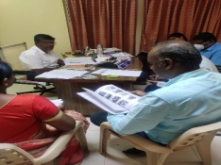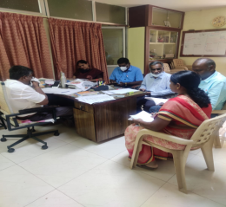  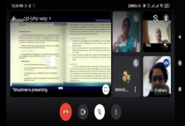
Mrs M.Mahalakshmi, Lecturer
- 1.2.2022 to 4.2.2022 – Involved in NISTHA module translation and pruning workshop as a resource person at SCERT, Chennai.
- 7.2.2022 to 9.2.2022 - NISTHA Module Translation and Correction Work was seen at DIET, Salem.
- 10.2.2022 – ICT Module Correction Work was seen at DIET, Salem.
- 11.2.2022 – NISTHA Evaluation Question Preparation work was seen at DIET, Salem.
- 14.2.2022 – NISTHA Yoga Module Correction Work at DIET, Salem was done.
- 15.2.2022 - NISTHA Module Translation work and 6th std Mathematics Module preparation work at DIET, Salem was done.
- 16.2.2022 - NISTHA 6th Module Translation Work at DIET, Salem was done.
- 21.2.2022 to 24.2.2022 – Attended Online School Leadership Development Workshop Program conducted by DIET, Kothagiri.
- 25.2.2022 – School Leadership Program Consolidation and NISTHA Module Translation Work was done.
- 28.2.2022 – Preparatory Work for Life Skill Education Training was done.
Educational Technology Branch (ET):
Mrs G.Dhanammal, Senior Lecturer
- 1.2.2022 – Prepared Programme and Activities proposal and Research Proposal Budget work at DIET, Salem was seen.
- 2.2.2022 – Action Research Google Form creation work was done.
- 3.2.2022 – Attended Staff Meeting regarding need based training programme.
- 4.2.2022 – Prepared and Coordinated Need Based Training List for Teachers.
- 8.2.2022 - Action Research Typing Work was done.
- 14.2.2022 - Action Research Documentation work was done.
- 15.2.2022 – Action Research module preparation work was seen.
- 16.2.2022 to 18.2.2022 – Prepared 6th std Questions for Social Science subject.
- 21.2.2022 to 27.2.2022 – Prepared Sense Life Map of “Satrapathi Sivaji”.
Dr V.Suganya, Lecturer
- 4.2.2022 - Ezhil - TTI Scholarship Verification Work was seen.
- 7.2.2022 – Prepared Action Research Abstract.
- 8.2.2022 & 9.2.2022 –December-2021 month Newsletter work was seen.
- 10.2.2022 – புலம்சார்வினாடிவினா – E- Quiz Prepared.
- 11.2.2022 – புலம்சார்வினாடிவினா - Flyer Prepared & Launched.
- 14.2.2022 to 15.2.2022 – January-2022 month Newsletter work was seen.
- 16.2.2022 to 17.2.2022 – Prepared E-Quiz Questions –உரைபடவினாடிவினா.
- 18.2.2022 - Prepared நிழற்படவினாடிவினா E-Quiz.
- 21.2.2022 – Action Research Documentation for Review & E-Quiz Flyer Preparation work was seen.
- 22.2.2022 – Thematic Paper Prepared for Tamil Nadu Open University (TNOU) for publication.
- 24.2.2022 – நிழற்படவினாடிவினா- Question Reviewed.
- 25.2.2022 – நிழற்படவினாடிவினா - Flyer Prepared.
Mrs M.Jayamani, Lecturer
- 01.02.2022 to 04.02.2022 Involved in NISTHA Training Module Translation work at SCERT, Chennai.
- 07.02.2022 – 22.02.2022 NISTHA Training Module Correction Work was seen at SCERT- Chennai.
District Resource Unit Branch :(DRU) :

Dr T.Prabhakaran, Senior Lecturer

- 2.2.2022 & 03.02.2022 – Visited Learning Outcomes Reinforcement Training centre at Panamarathupatti Block.

- 17.02.2022- Teachers Action Research work was seen.

Dr P.SO.Kesavan, Lecturer
Date | DETAILS OF WORK CARRIED OUT
1.2.2022 | Visited and gave input in the “Learning Outcome Refresher Training for Primary Teachers” at GHS,Chinnaseeragapadi.  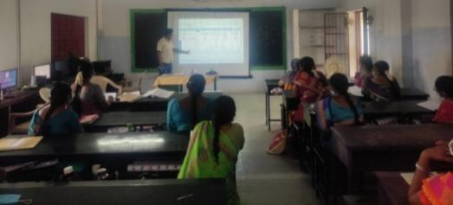
2.2.2022 | Visited and gave input in the “Learning Outcome Refresher Training for Primary Teachers” at GBHSS, Attayampatty .  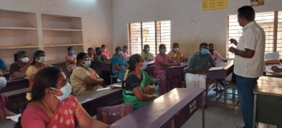
3.2.2022 | Attended “Microsoft Innovative Educators”- MIE Training conducted by Microsoft.  A/N: Attended Faculty Meeting -Regarding suggestions for utilizing DIET infrastructure and faculty.
7.2.2022 | Action Research abstract prepared for the year 2021-2022
8.2.2022 | Teachers’ Action Research -Visited PUMS, Irusanampatty and gave guidance to the teacher.
9.2.2022 | Reading :Articles related to Challenges of online learning
10.2.2022 | Reading : SWAYAM – e Assessment -Course materials
11.2.2022 | Action Research Report Correction work carried out
21.2.2022, | “ROLE PLAY “ Competition – Coordination work – Executed-Videos downloaded sent by schools through e-mail
22.2.2022 &
23.2.2022
24.2.2022 | Coordinated “District Level “ROLE PLAY” Competition at DIET,Uthmasolpuram, Salem.  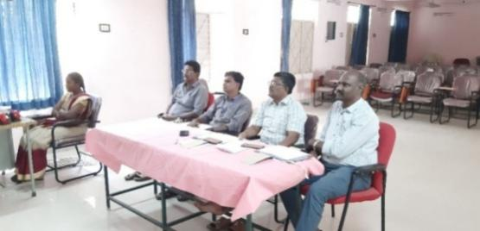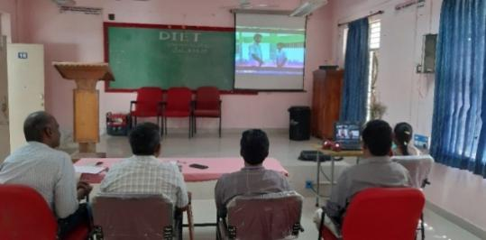
25.2.2022 | Teacher Action Research Report Correction work was carried out

Curriculum Material Development and Evaluation Branch ( CMDE) :
Dr R.Nagalakshmi, Senior Lecturer
1. Visited and gave inputs on Learning Outcomes- Science Training for Primary Teachers on 01.02.2022.
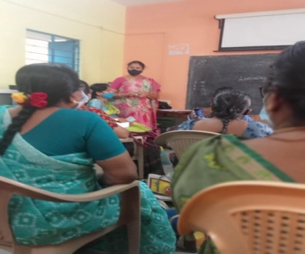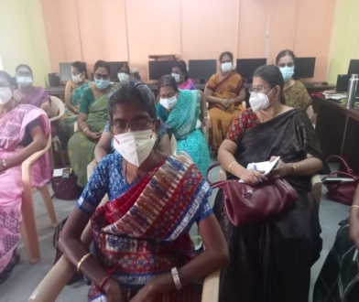
2. Conducted Research Project Intervention to SGTs on SOLO Taxonomy at BRC, Valapady on 04.02.2022
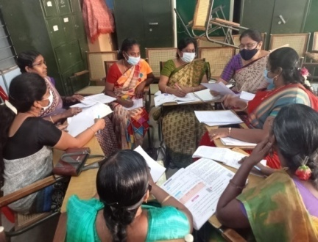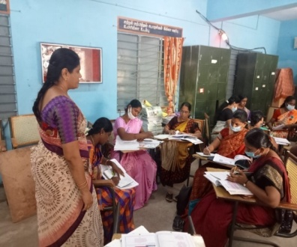
3. State Level Capacity Building Curriculum Framework workshop at Yelagiri, with TN Education Department Commissioner, SCERT Director, JD and Azim Premji University RPs from 09.02.2022 to 11.02.2022 .
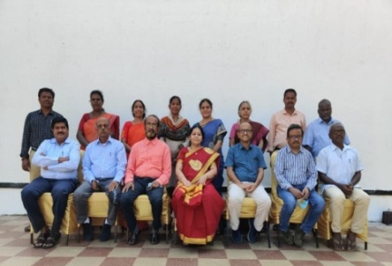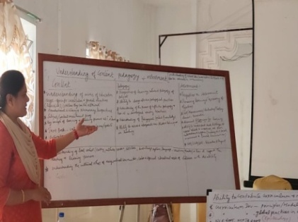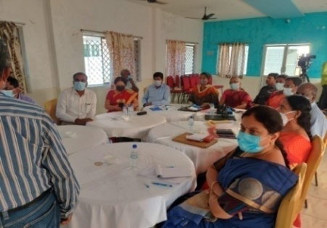
4. Participated in the School Leadership Academy Workshop at DIET, Salem from 21.02.2022 to 24.02.2022
Dr B. Ananthi,Lecturer
1. Dictionary - Pruning Workshop at DIET, Salem from 01.02.2022 to 03.02.2022, organised by SCERT, Chennai.
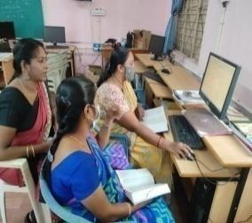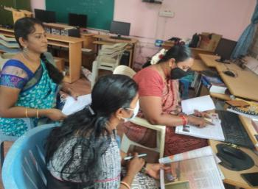
2. Participated in the School Leadership Academy Workshop at DIET, Salem from 21.02.2022 to 24.02.2022.
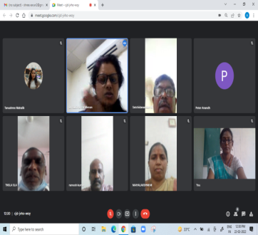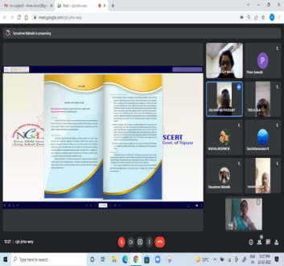
Work Experience Branch :( WE)
Dr S.Vijayalakshmi Shankar, Senior Lecturer
Date | ACTIVITIES
01.2.2022 &  02.2.2022 | Preparation of AWP&B work and Consolidation work of all AWP&B was done.
03.2.2022 | Attended Microsoft Training by MS Teams.
06.2.2022 | Conducted Through Zoom App- “AASAN ORU PUDUMAI” -12-Special programme-DIET & Rotary MoU -Resource Person Mr.Sivakumar, HM,PUPS, Vanniyanoor, Meecheri. -Topic: “Yem Palliyen Kathai”.
07.2.2022 | Research Project-discussion with expert.
08.2.2022-12.2.2022 | X-Standard -Science Taxonomy Workshop was seen at SCERT , Chennai
13.2.2022 | Conducted Through Zoom App-AASAN ORU PUDUMAI -13-Special programme-DIET & Rotary MoU -Resource Person Mr.Muniyappan, Lecturer,DIET,Krishnagiri. -Topic: “Ellathuariyum Ragasiyagal”
14.2.2022-19.2.2022 | V-Standard Science Taxonomy Workshop was seen at SCERT, Chennai.
20.2.2022 | Conducted Through Zoom App-AASAN ORU PUDUMAI -14-Special programme-DIET & Rotary MoU -Resource Person Dr.G.Senthilkumar, Chairman Gelix School,Salem. -Topic: “Information Processing”
21.2.2022 &  22.2.2022 | Research Project -Chapter 2 -Review Drafting work was done.
24.2.2022 | Attended National Conference on NEP 2020 : Towards Transforming Teacher Education -conducted by RIE ,Bhubaneswar –NCERT
25.2.2022 | Paper Presented in the NCNEP 2020TE- Programme 2022 through ZOOM App.
26.2.2022 | Attended National Conference on NEP 2020 : Towards Transforming Teacher Education -conducted by RIE ,Bhubaneswar –NCERT
27.2.2022 | Conducted Through Zoom App-AASAN ORU PUDUMAI -15-Special programme-DIET & Rotary MoU -Resource PersonMr.Balu, HM, PUPS, Keechagkuppam. -Topic: “Sunami to Seertharam

Mr C.Anbarasan, Lecturer.
- Taxonomy review work for XI & XII Std Chemistry subject was done.
Dr K.Kalaivanan, Lecturer.
- Attended Microsoft training on 03.02.2022.
- Question and Answer prepared for 6th Std Tamil subject on 04.02.2022.
- Question and Answer prepared for 7th Std Tamil subject on 07.02.2022.
Mr K.Satchidanandam,Librarian
- Creation of Book Database (data entry) for library books was done.
- Bar coding of library books were continued.
- Action research project preparation work was done.
- Documented and listed out DIET Modules, Training reports, etc... for library and DIET faculty reference purpose.
- Need based coordination work with E.T branch.
- Need based referral service to DIET faculty members.
- Attended Microsoft -360 training programme by Microsoft Teams.

Mr P.Ravichandran, Statistics (ADS):
- Attended GDP meeting at District Collectorate, Salem.(On Every Monday)
- Consolidated monthly reports of DIET Branch Activities.
- Collected Primary, Upper Primary, Secondary & Higher Secondary teachers list from SSA and BRC Salem.
- Consolidating of DIET Calendar of Activities Report.

Chief Editor : Dr M.SELVAM,
PRINCIPAL
Uthamacholapuram,
Salem-636010
Editors : G.DHANAMMAL (SL)
Dr V.Suganya (L)
Associate Editor : Mrs.S.Selvi (L)
(PSTE Branch)
This Newsletter is Prepared and Published by ET Branch-DIET,Salem.
Phone : 7373003460
Email : dietslm@gmail.com
Website : www.dietsalem.com

